**Question 31 (21 marks)**

Ebola Virus Disease, EVD, is highly virulent in humans. It was first detected in 1976, with the largest ongoing outbreak being in West Africa. Development of a marketable vaccine has yet to be achieved, with VSV-EDOV still in phase III of development.

1. If Ebola is a virus, can it be treated with antibiotics? (1 mark)

**No**

1. State three non-specific external defences that a human has and describe how they could prevent entry of the Ebola virus. (3 marks)

**Any three, must include reason**

* **Skin – a barrier so cannot pass through unless cut**
* **Mucus membrane – stick to mucus so cannot pass or enter cells**
* **Hairs of nose/ears – mucus between hairs will trap virus**
* **Cilia – beat virus away from cells**
* **Ear wax/cerumen – virus will stick to so cannot pass**
* **Flushing action – bladder/sweat/tears/saliva, wash virus away**

1. Viruses act in different ways to bacteria when they enter the human body. Explain how a pathogenic virus such as Ebola acts after entering the body to cause a disease. (3 marks)

**Any three points from:**

* **Bind to receptor on cell membrane**
* **Inserts its own DNA or RNA**
* **Host cell manufacture new virus particles**
* **Host cell ruptures**
* **New viruses then released**

1. To diagnose a person with Ebola, an antigen-capture detection test can be used.
2. What is an antigen? (1 mark)

Anything that can cause an immune response in the body

1. Explain why identifying the Ebola antigen could help the World Health Organisation develop a vaccine for Ebola. (1 mark)
2. **Once antigen identified, can modify it/attenuate it/create a sub-unit to create a vaccine**

**OR**

1. **Vaccines work by introducing the body to a harmless version of the antigen, if the antigen is unknown cannot create a vaccine.**
2. **OR – once identified vaccine can be made and given to many members – to reduce spread (Herd Immunity)**
3. In recent outbreaks of Ebola some people have survived an infection and made a full recovery
4. Describe three ways an antibody can work to provide resistance to infection. Use any scientific names used.

**Any three ways**

**6 marks**

* + - **Combine so inhibit reaction with cells**
    - **Bind to antigen so prevent entry into cells**
    - **Agglutinate so can be digested/cannot enter a cell**
    - **Dissolve antigen**
    - **Turn a soluble antigen into an insoluble antigen**
    - **Bind to virus surface preventing entry into cells**
    - **Opsonisation where macrophages are attracted to the antigen.**

1. Explain why a person who has recovered from Ebola can give blood to a person with Ebola and it may help them survive. (2 marks)

Blood contains Memory B and T white blood cells (1 mark) that can identify and respond to the virus(1 mark).

1. Using the information in the graph, discuss why it is unlikely that a person that has had Ebola and has recovered is unlikely to get the disease again.

Must mention memory cells and 3 other points from the following: (4 marks)

* **First exposure causes humoral response/antibody mediated response**
* **Production of memory cells**
* **if virus enters again memory cells recognise the virus/antigen quickly**
* **so the response is much quicker/plasma cells form very quickly**
* **antibody levels rise quickly in the plasma**
* **so destruction of the virus is quick preventing the person getting Ebola again/too quick for antigen to have any noticeable effect.**
* **No or minimal symptoms**

**Question 32 (13 marks)**

1. Write a suitable hypothesis for this experiment. (1 mark)

**Hypothesis must state how independent variable affects dependent variable (increase/decrease/no effect)**

***e.g. Levothyroxine reduces average blood cholesterol/LDL levels.***

1. State two variables that would need to be controlled that are not mentioned(2 marks)

**Any two**

* **Age of subjects same**
* **Gender of subjects same**
* **Amount/dose of drug/placebo needs to be the same**
* **Diet would need to be the same**
* **Exercise levels would need to be the same**

1. What is a placebo? (1 mark)

**A substance that has no active chemicals used for comparison**

1. Plot a graph of the information contained in the table. (5 marks)

Average blood cholesterol of patients taking levothyroxine or a placebo over 8 week period.

Levothyroxine

Placebo

195

190

185

180

175

170

165

160

155

150

145

140

Average blood cholesterol levels (mg/dL)

|  |  |  |  |  |  |  |  |  |  |  |  |  |  |  |  |
| --- | --- | --- | --- | --- | --- | --- | --- | --- | --- | --- | --- | --- | --- | --- | --- |
|  |  |  |  |  |  |  |  |  |  |  |  |  |  |  |  |
|  |  |  |  |  |  |  |  |  |  |  |  |  |  |  |  |
|  |  |  |  |  |  |  |  |  |  |  |  |  |  |  |  |
|  |  |  |  |  |  |  |  |  |  |  |  |  |  |  |  |
|  |  |  |  |  |  |  |  |  |  |  |  |  |  |  |  |
|  |  |  |  |  |  |  |  |  |  |  |  |  |  |  |  |
|  |  |  |  |  |  |  |  |  |  |  |  |  |  |  |  |
|  |  |  |  |  |  |  |  |  |  |  |  |  |  |  |  |
|  |  |  |  |  |  |  |  |  |  |  |  |  |  |  |  |
|  |  |  |  |  |  |  |  |  |  |  |  |  |  |  |  |
|  |  |  |  |  |  |  |  |  |  |  |  |  |  |  |  |
|  |  |  |  |  |  |  |  |  |  |  |  |  |  |  |  |
|  |  |  |  |  |  |  |  |  |  |  |  |  |  |  |  |
|  |  |  |  |  |  |  |  |  |  |  |  |  |  |  |  |
|  |  |  |  |  |  |  |  |  |  |  |  |  |  |  |  |

0 1 2 3 4 5 6 7 8

Number of weeks (weeks)

**Bar graph – maximum three points**

* **Points plotted correctly and joined to form a line**
* **Title must include independent and dependent**
* **X and Y axis labelled correctly, including units**
* **Axes constructed using appropriate scale (at least half the grid)**
* **Each line labelled/shown in a legend/key**

1. What conclusion can be drawn from the results? (2 marks)

**E.g.**

The results do/do not support the hypothesis(1). Restate(1)

1. Is this conclusion valid? Explain your answer. (2 marks)

**Yes** (1) **conclusion reached is supported by data in a controlled experiment(1).**

**Question 33 (11 marks)**

1. Describe the role of the structure labelled “A”. (1 mark)

**Receive nerve impulses from other neurons**

1. Name and state the functions of the cells labelled “B”? (3 mark)

**Schwann cell(1) forms the myelin sheath(1) insulates the axon(1) or helps speed up impulse transfer.**

1. Explain what is occurring at the phase indicated by the letter ”C” on the graph in terms of ion movement and membrane potential. (3 marks)

**Sodium channels open,**

**sodium ions move in,**

**cell membrane becomes depolarised**

1. Discuss the differences between how a nerve impulse is conducted along a myelinated and unmyelinated nerve fibre. (4 marks)

**Unmyelinated – action potential moves along membrane continually (1)**

**Slower than myelinated (1)**

**Myelinated - action potential jumps from node of Ranvier to node of Ranvier or explanation of salutatory conduction (1)**

**Impulse travels quickly/quicker than unmyelinated (1)**

**Question 34 (12 marks)**

1. The nervous system has several different systems which all have quite specific functions. Using the table below, state one comparison between the following nervous systems.

(2 marks)

|  |  |
| --- | --- |
| **Two systems to compare** | **Main difference** |
| Afferent division vs Efferent division of the peripheral nervous system | **Afferent carry impulse toward CNS and efferent carrying impulse away from CNS** |
| Central nervous system compared to the peripheral nervous system | **CNS – brain and spinal cord coordinate movement/body functions**  **Peripheral – (central nerves and spinal nerves) connect the muscles and glands with CNS** |

The diagram below is of the human brain.

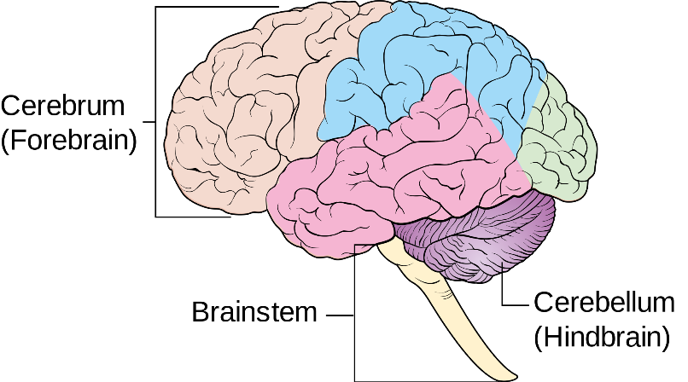

**Medulla oblongata**

**Occipital lobe**

1. On the diagram, label or shade the following three areas: (2 marks)
2. the occipital lobe.
3. Medulla oblongata
4. The brain and the spinal cord are very delicate and as they are vital to human survival they must be protected. One structure that provides protection for these two parts is the meninges.

(i)Name the structure other than the meninges that helps protect the brain. (2 mark)

**Cranium (1)of the skull(1)**

(ii)Name and explain the role of the fluid within the meninges. (3 marks)

**Cerebrospinal fluid(1)**

**Any 2 of**

**Acts as shock absorber, cushioning blows/shock (1)**

**Suspends the brain/brain floats/supports the brain (1)**

**Delivers nutrients and removes waste (1)**

**Buffers temperature change(1)**

d) The human brain is divided up into several sections, each with its own set of specific functions. Complete the table below by summarising the main function of each area shown. (2 marks)

|  |  |
| --- | --- |
| **Structure** | **Function** |
| Cerebral Cortex | **Involved in mental activities, perception of the senses, control of voluntary muscle contraction,**  **sensory areas interpret impulses from receptors, motor areas control muscular movements.**  **Problem solving. Higher order intelligence.**  **Any two** |
| Cerebellum | **Fine coordination of movement** |

1. During a mining accident, a gentleman received substantial damage to his medulla oblongata when a metal pipe hit him from behind.

Describe one difficulty the man might experience as a result of this damage to the medulla oblongata and explain why. (2 marks)

***High chance of death(1)***

**This is because the medulla oblongata helps regulate breathing and heart func*tion*. OR This part of the brain is a centre for respiration and circulation.(1 mark)Question 35 (9 marks)**

Many retired soldiers have made the trip to Papua New Guinea to walk the Kokoda Track in memory of the Kokoda Trail campaign fought during World War II. The track is considered very difficult due to the extreme humidity and heat, but if people look after themselves properly during the trek, the track is manageable.

1. Describe one problem that extreme humidity could cause for individuals walking the track. (1 marks)

**Sweat will not evaporate**

1. The control of the body’s internal environment is essential if the person is going to be able to function properly and respond to the demands of such an arduous task of walking the track.

Complete the feedback loop shown below to show how heat loss can be increased from the body to prevent overheating. Do not include the behavioural response. (5 marks)

**Response**

**Vasodilation of blood vessels of skin(1)**

**Sweating(1)**

**Effector**

**Sweat glands(1)**

**Blood vessels of skin(1)**

**Modulator**

**Hypothalamus(1)**

**Negative Feedback**

Drop in core body temp(1)

**Stimulus**

High Body temperature

**Receptor**

**Core thermo receptors in the hypothalamus, spinal cord and gut**

**(1)**

**Max=5**

1. The feedback loop is an effective mechanism for maintaining the body’s core temperature. However the process of sweating initiated by the effector can cause other problems for the body.
2. Name one problem the processes brought about by the effector could produce?

**(1 mark)**

**Dehydration (1)**

1. Explain the difference between a positive feedback loop and a negative feedback. (2 marks)

**Negative feedback system works to reduce the stimuli.(1)**

**Positive feedback system works to increase the stimuli.(1)**

**Question 36 (5 marks)**

A reflex is a rapid response to a change in the internal and external environment.

The diagram below shows the main components of a reflex arc.

2.

3.

4.

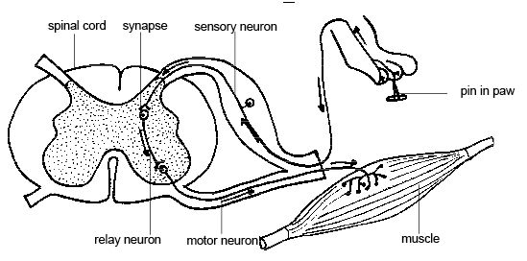

1.

5.

6.

1. Identify the main components of the reflex arc indicated by the arrows on the diagram above. (3 marks)
2. A reflex is classed as part of a human’s non-specific defence system. Explain the reasoning for this. (2 marks)

**Protective reflex protects the body from injury or infection (1) OR**

**Can be by forcing a foreign antigen out from the body so it cannot cause harm eg vomiting, sneezing(1)**

**To maintain homeostasis (1)**

**Question 37 (12 marks)**

1. Pathogens are disease causing organisms. The most common types of pathogens are bacteria and viruses.

State one other type of organism that can act as a pathogen.

(1 marks)

**Fungi or parasitic animal.**

1. Malaria is caused by the plasmodium parasite. The parasite is spread by the female Anopheles mosquitoes, which are known as "night-biting" mosquitoes because they most commonly bite between dusk and dawn. What is this type of transfer called?

(1 mark)

**Vector**

_________________________________________________________________

1. List 3 purposes for the Inflammatory response

(3 marks)

Any 3

**Reduce the spread of pathogens**

**Stop further pathogens entering the body**

**Remove damaged tissue and cell debris**

**Begin repair of damaged tissue**

1. Name and state the function of the two chemicals released during the Inflammatory response.

(4 marks)

|  |  |
| --- | --- |
| Chemical | Function |
| Histamine (1) | Increases blood flow to affected area  (1) |
| Heparin (1) | Prevents clotting  (1) |

_________________________

1. The vomiting reflex helps remove pathogens and potential pathogens from the digestive tract. State the stimulus for this reflex and the body structures involved in bringing it about.

(3 marks)

|  |  |
| --- | --- |
| STIMULI | Stretching of stomach  Bacterial toxins  Psychological effect  Any one(1) |
| Structure involved | Diaphragm (1)  Abdominal muscles (1) |

**Question 38 (17 marks)**

Type II diabetes affects around 120,000 Australians. It is caused when the body’s own immune system attacks its own cells and prevents parts of the endocrine system from functioning normally.

1. Insulin is a protein based hormone. Explain how these types of hormones work. (2 marks)

Attach to receptor proteins on target cell membrane(1)

Causes secondary messenger substance to diffuse through cell(1)

1. What type of cells produce insulin and where can they be found? (1 mark)

Beta cells in the islets of Langerhans(1) or pancreas.

1. Describe how insulin controls glucose levels in the body. (2 marks)

**Causes glucose to be converted to glycogen(1) in the liver(1). Or can say causes glycogenesis in the liver.**

1. Which hormone causes Glycogenolysis? Also state where it is produced and its target organ.

(3 marks)

**Hormone=glucagon(1)**

**Produced alpha cells of islets of Langerhans(1)**

**Target cells liver(1)**

1. Type 2 diabetes is often referred to as a lifestyle disease. What is meant by a lifestyle disease and state two factors that might increase a person’s chances of developing type 2 diabetes.

(3 marks)

Disease caused by poor lifestyle choices(or something similar)(1)

Any two of the following

Being obese(1)

Too much processed sugar in diet(1)

Inactivity(1)

Smoking(1)

1. The microorganism shown below was found to be pathogenic. The investigators stated that the microorganism were bacteria and not viruses.

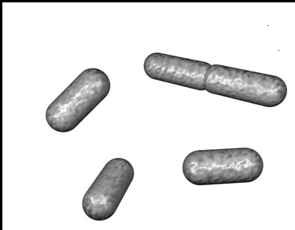

1. Which characteristics would the investigators use to distinguish this as a bacteria and not a virus?

(3 marks)

Any three of the following

If bacteria it would be able to replicate outside of a host cell.

Bacteria can be seen with a light microscope, virus can only be seen with an electron microscope.

Bacteria have internal organelles, virus do not.

Virus have protein outer coat, bacterial have a cell wall.

Bacteria can have both DNA and RNA. Virus only have DNA or RNA not both.

1. As the microorganism has already been classified as a bacteria, how could the bacteria be further classified? Giving a reason for your choice, which bacterial group would you classify this microorganism as?

**Classified by shape(1)**

**Bacilli(1)**

**Rod shaped(1)**

(3 marks)